**Basics of Agile – Assessment Completed**

Extreme team delivery compulsory

**AGENDA - SLIDE 2**

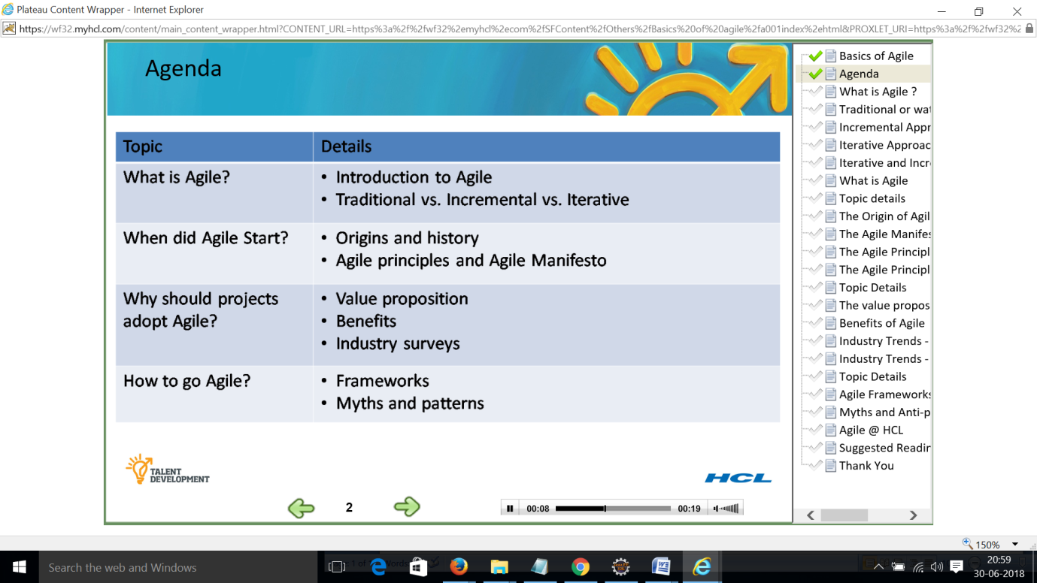

**WHAT IS AGILE ? – SLIDE 3**

Delivery of high quality software that is of high business value using sound engineering practices

Tight alignment of business and technology

Adaptive embraces change in requirements and Business priorities

Light weight processes set with minimal overheads

Iterative short time boxed development cycles releasing functional software at end of every iteration

Incremental continuously improving processes and practices every iteration with frequent planning

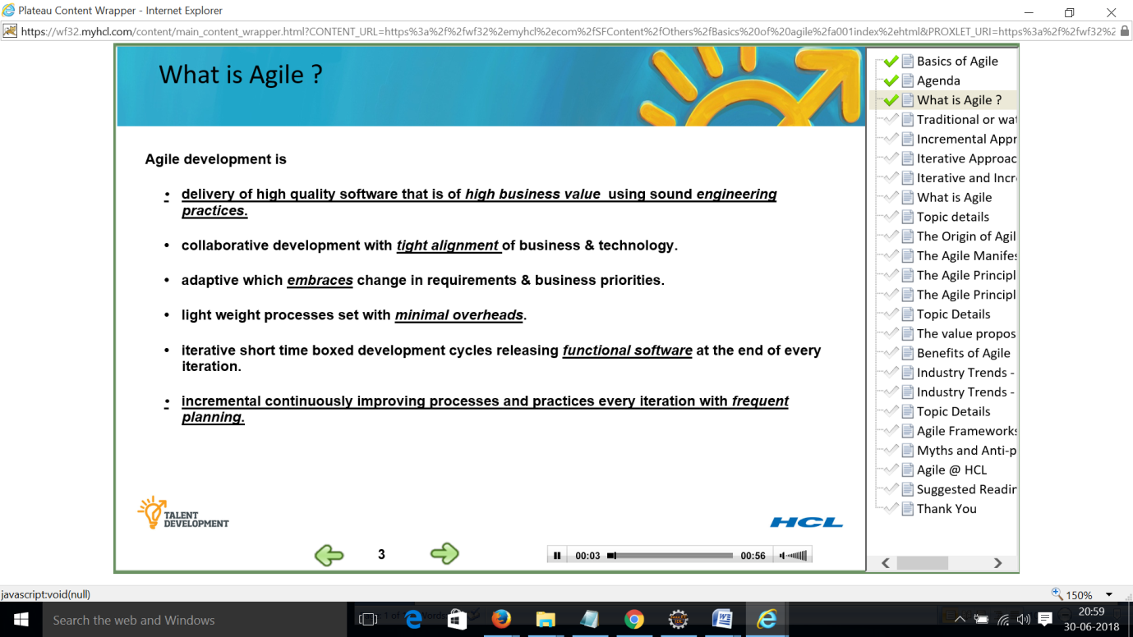

**TRADITIONAL WATERFALL APPROACH – SLIDE 4**

Disadvantages

Requirement, design, coding, testing, rework

Documentation based sign off

Move out the project by the time coding started leaving a gap

Project duration more than a year 18 months

First time customer seeing the tangible functional working software

is huge – big bang release

Long haul release to small releases with incremental features e.g. Flipkart

Starting with book selling now selling so many products

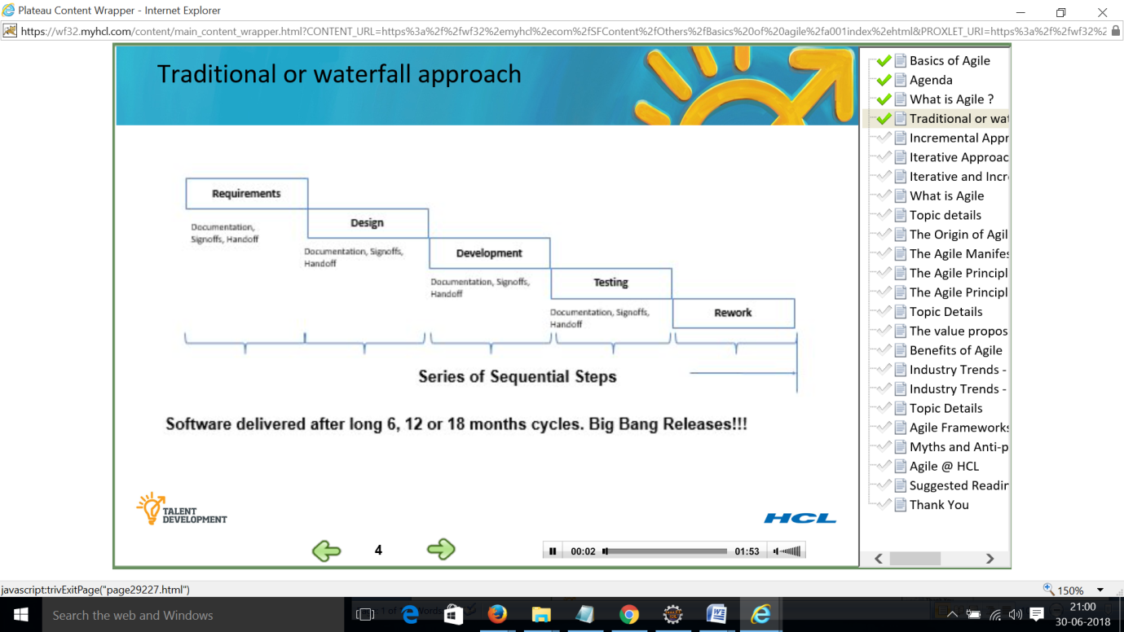

**Incremental Approach – SLIDE 5**

Each chunk undergoes entire SDLC

Adv – team gets to work on small chunk and gets feedback on daily basis. After delivery of each chunk, team has time to review and correct any coarse mistake as seen in the picture.

This mitigates failures and there is no surprise at the end of the project.

Things are built incrementally until the final picture emerges at the end of the project

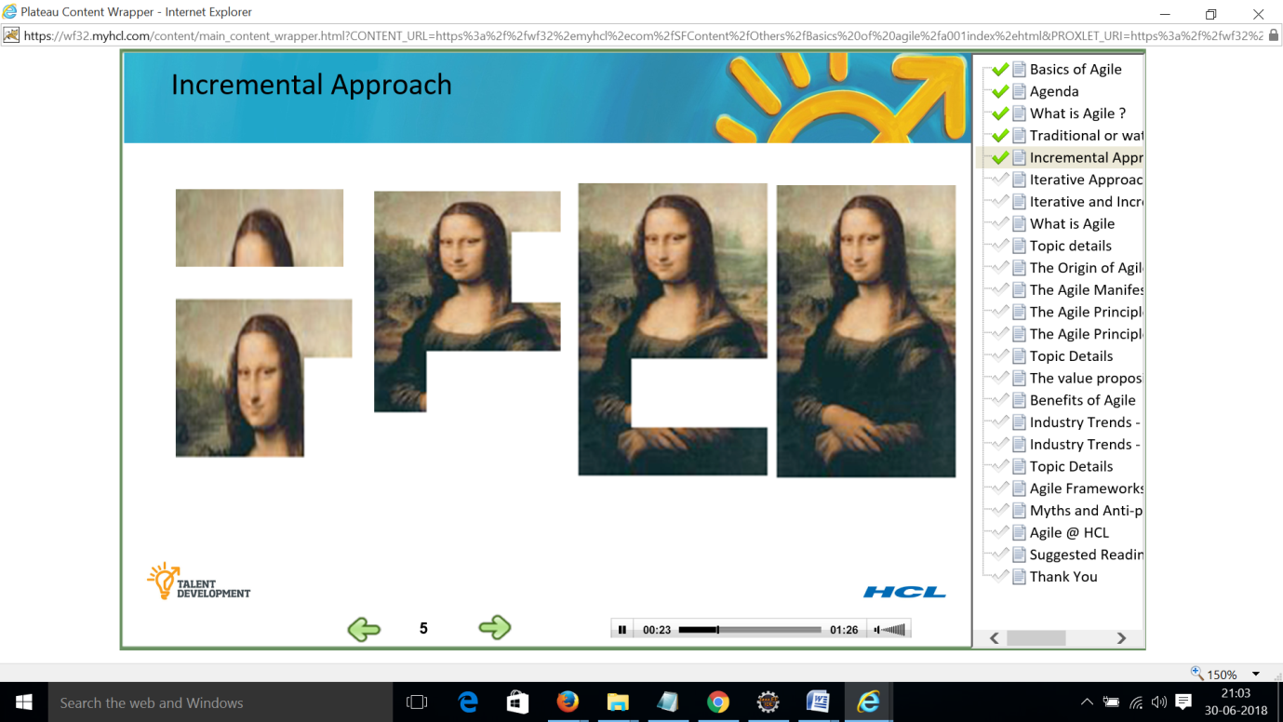

**Iterative approach – SLIDE 6**

Rework scheduling strategy received from stake holders.

Based on feedback Iterations are small duration. Product is refined and improved during course of project. End picture emerges incrementally.

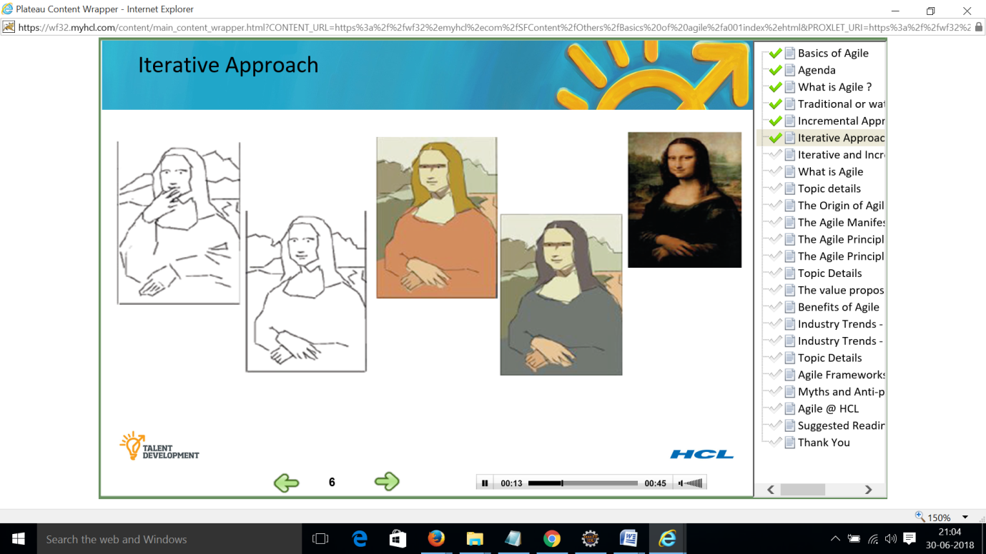

**Iterative and incremental approach**

**Iterative and incremental approach – SLIDE 7**

The large requirements are broken down into smaller chunks. Every chunk is developed in small iterations which are time boxed cycles.

Each iteration takes feedback from the user and incorporates the same into the next iteration

Benefit of both the approaches are merged together to ensure high quality delivery of software needed by stakeholder flexibility to accomodate the changes as we keep getting feedback ---

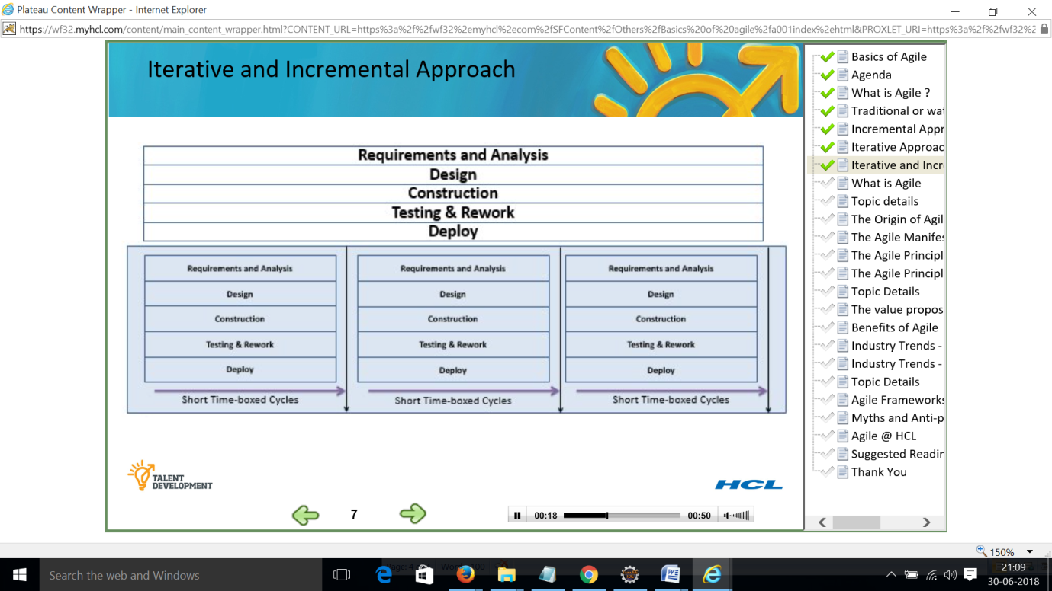

**WHAT IS AGILE – SLIDE 8**

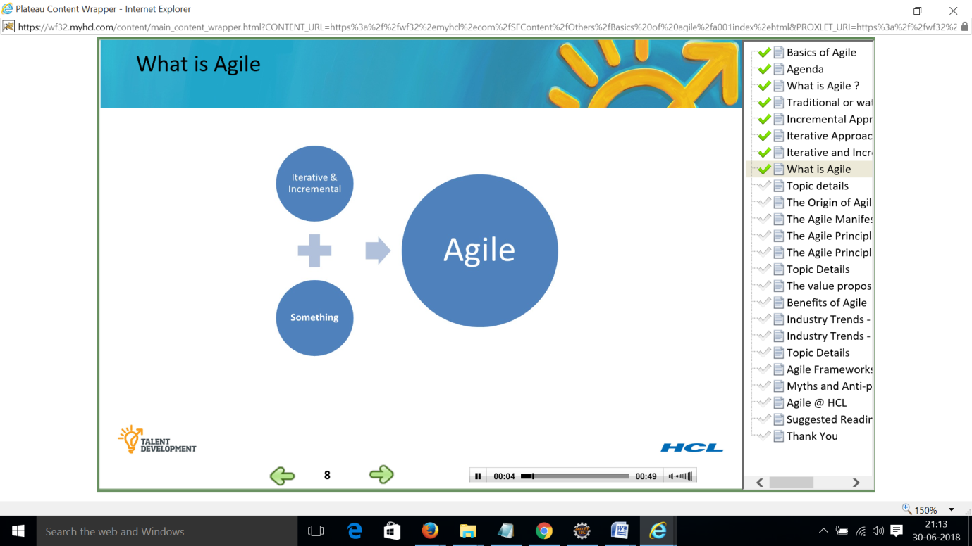

**TOPIC DETAILS – SLIDE 9**

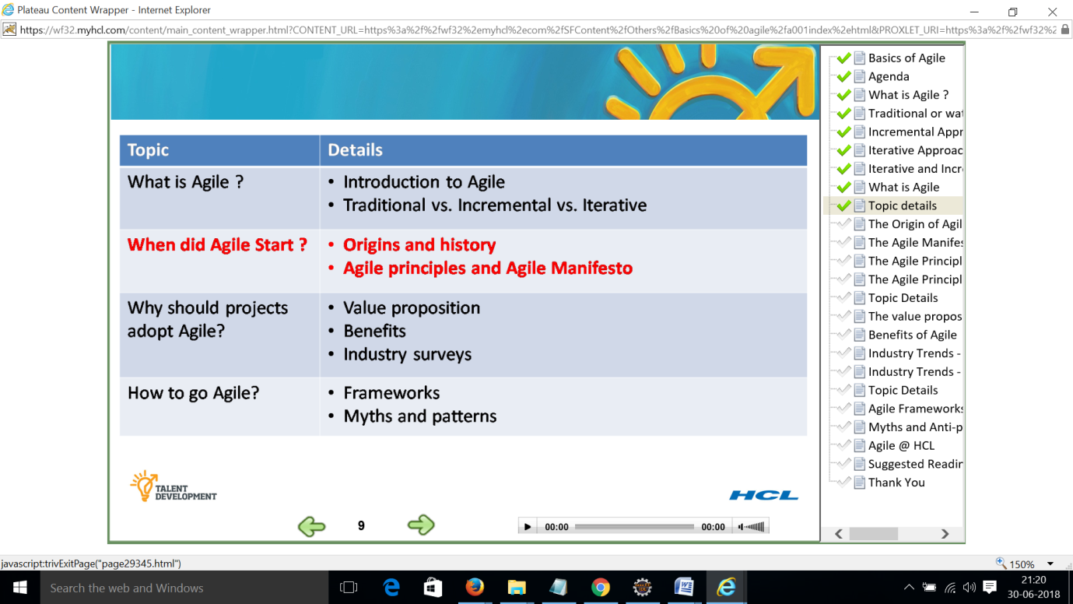

**THE ORIGIN OF AGILE – SLIDE 10**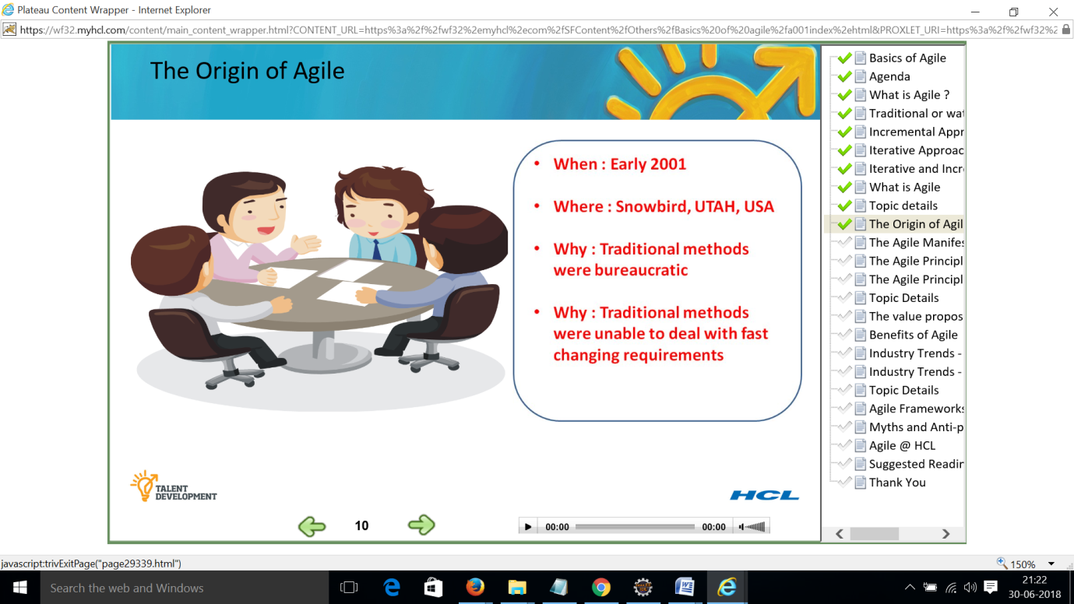

**THE AGILE MANIFESTO - SLIDE 11**

Uncovering better ways of developing software by doing it and helping other do it. Through this work we have come to value

Individuals and interactions over processes and tools

Working software over comprehensive documentation

Customer collaboration over contract negotiation

Responding to change over following a plan

Value items on the left more

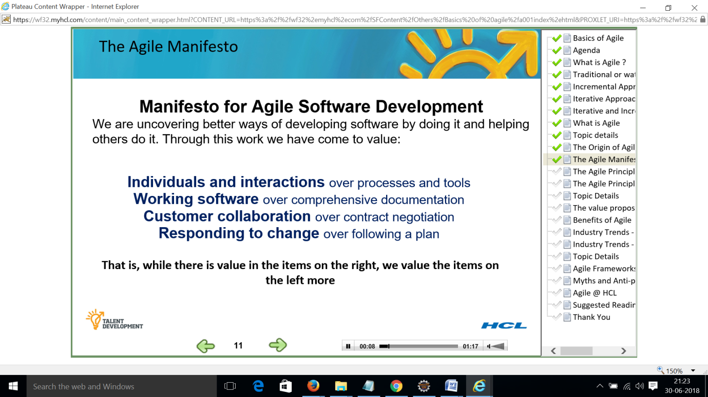

**THE AGILE PRINCIPLES – SLIDE 12**

Backbone of agile processes

Early and continuous delivery of valuable software

Welcome changing requirements even late in development. Agile processes harness change for customer’s competitive advantage

Deliver working software frequently from couple of weeks to couple of months

with preference to shorter time scale

Business people and developers must work together daily throughout the project

Build projects around motivated individuals

Efficient and effective method of conveying information to and within a development team is face to face conversation.

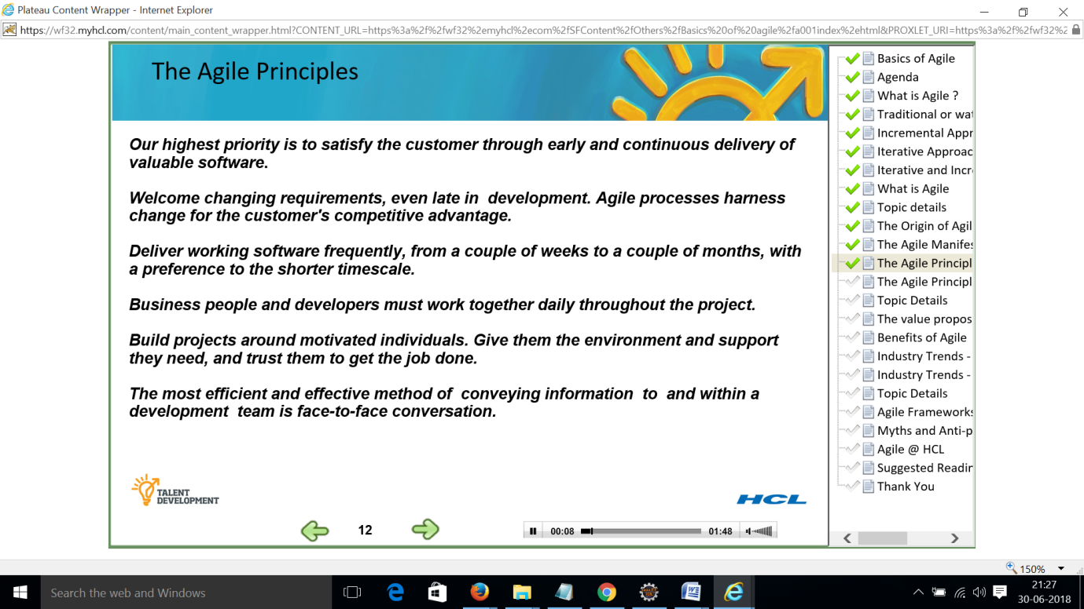

**THE AGILE PRINCIPLES CONTD – SLIDE 13**

Working software is primary measure of progress

Keep things as simple as possible.

Reflecting the process and correcting the same. Any correction is implemented immediately. retrospective –

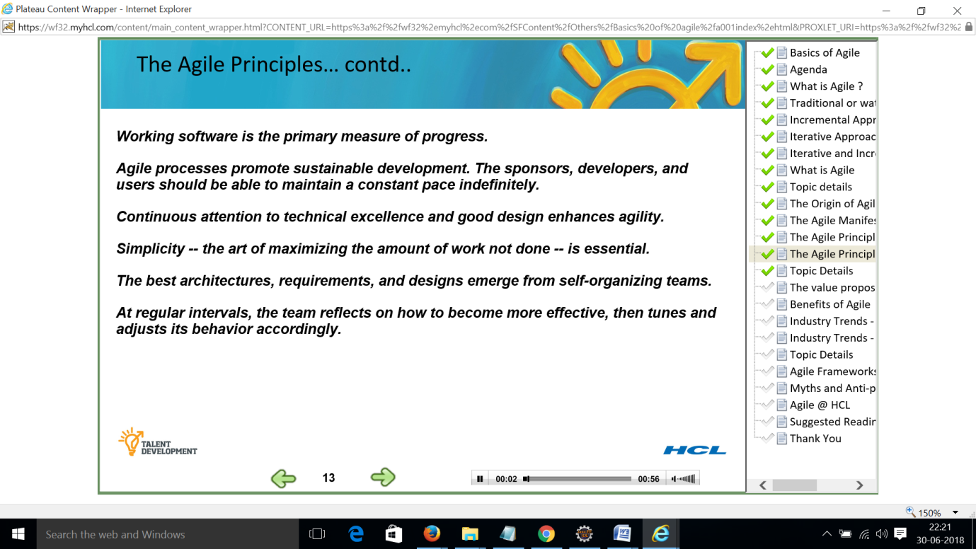

**TOPICS – SLIDE 14**

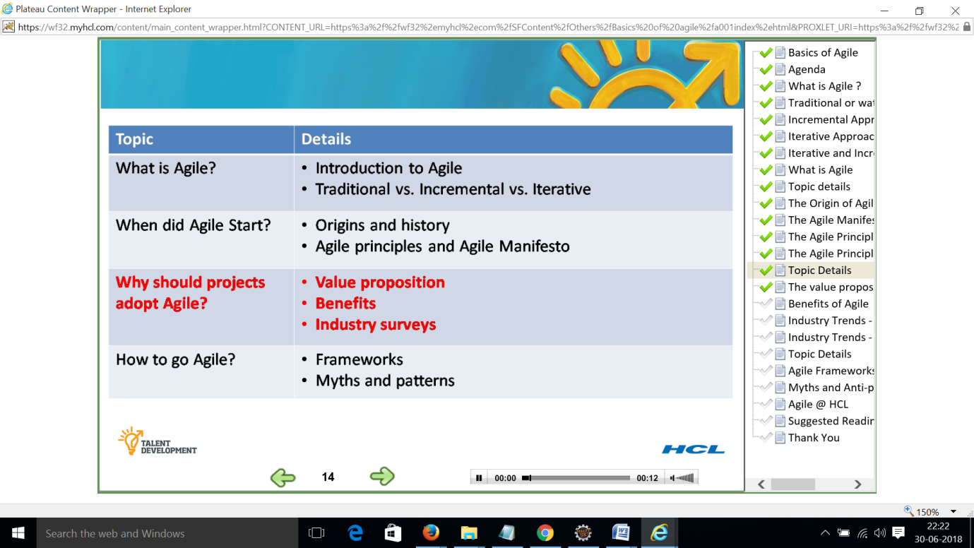

**THE VALUE PROPOSITION – SLIDE 15**

Agile methods promises High business value visibility transparency

Software delivered is of real use to the end customer

High visibility all through the project

Increased adaptability all through the project life cycle

High and increased business value

Risk reducing drastically as compared to traditional software delivered only toward end of project requirement has changed due to business environment technology changes regulatory changes etc. Long running projects etc.

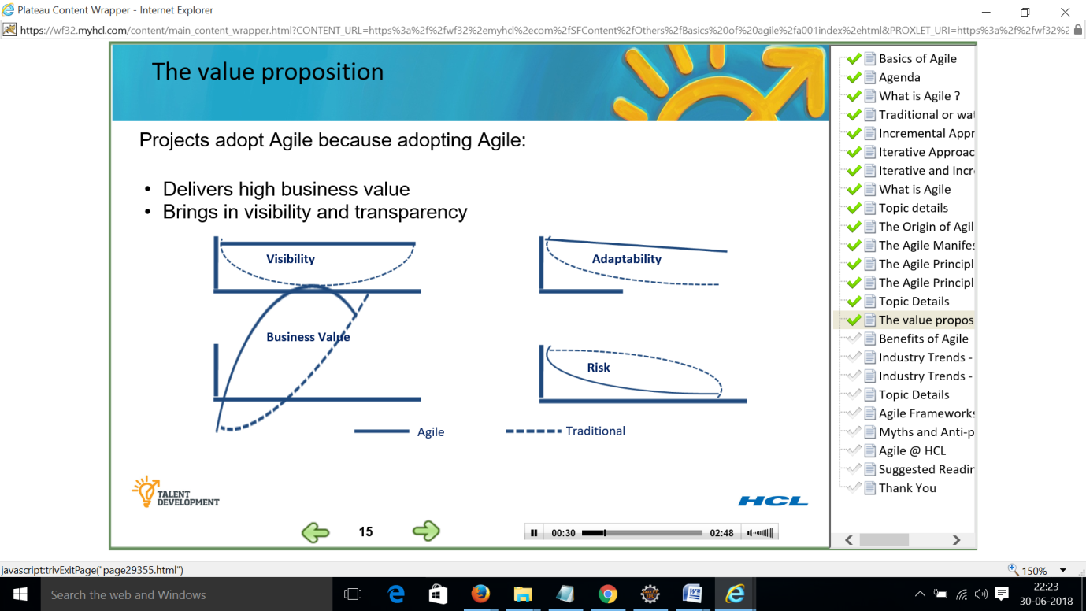

**BENEFITS OF AGILE – SLIDE 16**

**Development** benefits

Ownership and responsibility

Produce higher quality deliverables

Continuous business interaction

Quick feedback

Improved employee engagement and job satisfaction

**Business** benefits

Faster time to market

Adapting to changing business requirements

Mitigate risk earlier

Improved stakeholder satisfaction

Lower cost and higher productivity

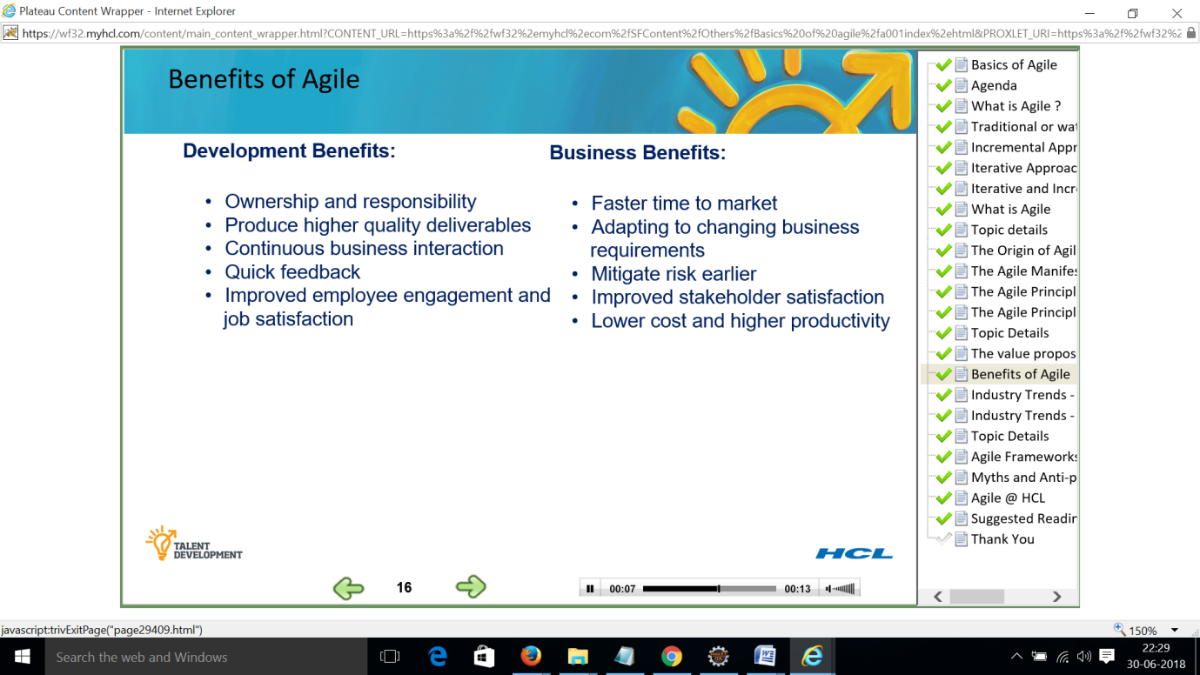

**INDUSTRY TRENDS –WHY AGILE - SLIDE 17**

Accelerate product delivery - 62%

Enhance ability to manage changing priorities – 56%

Increase productivity - 55%

Enhance software quality - 47%

Enhance delivery predictability - 44%

Improve business IT alignment - 44%

Improve project visibility - 40%

Reduce project risk – 40%

Improve team morale – 29%

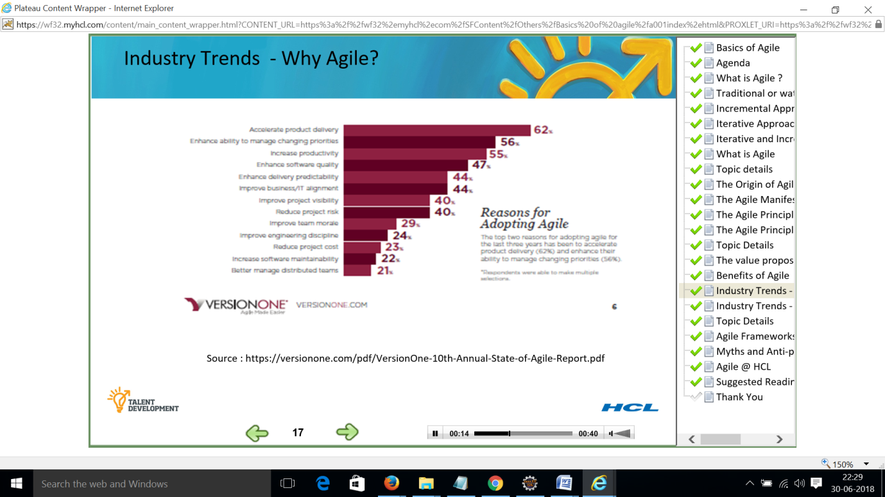

**INDUSTRY TRENDS – BENEFITS OF AGILE – SLIDE 18**

Ability to manage changing priorities

Increased team productivity

Improved project visibility

Increased team morale, motivation

Better delivery predictability

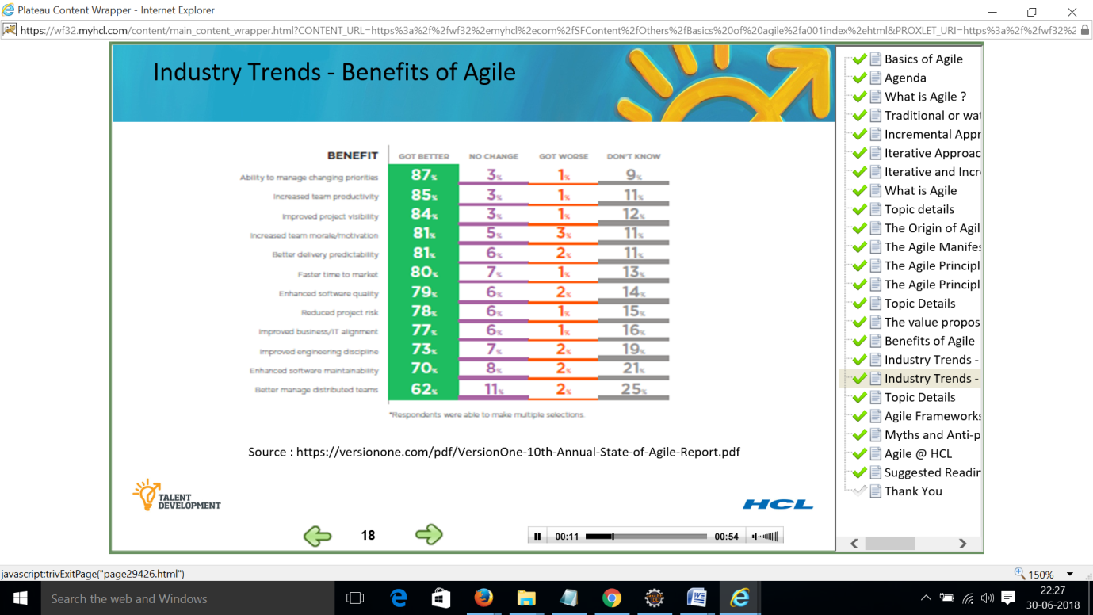

**TOPIC DETAILS – SLIDE 19**

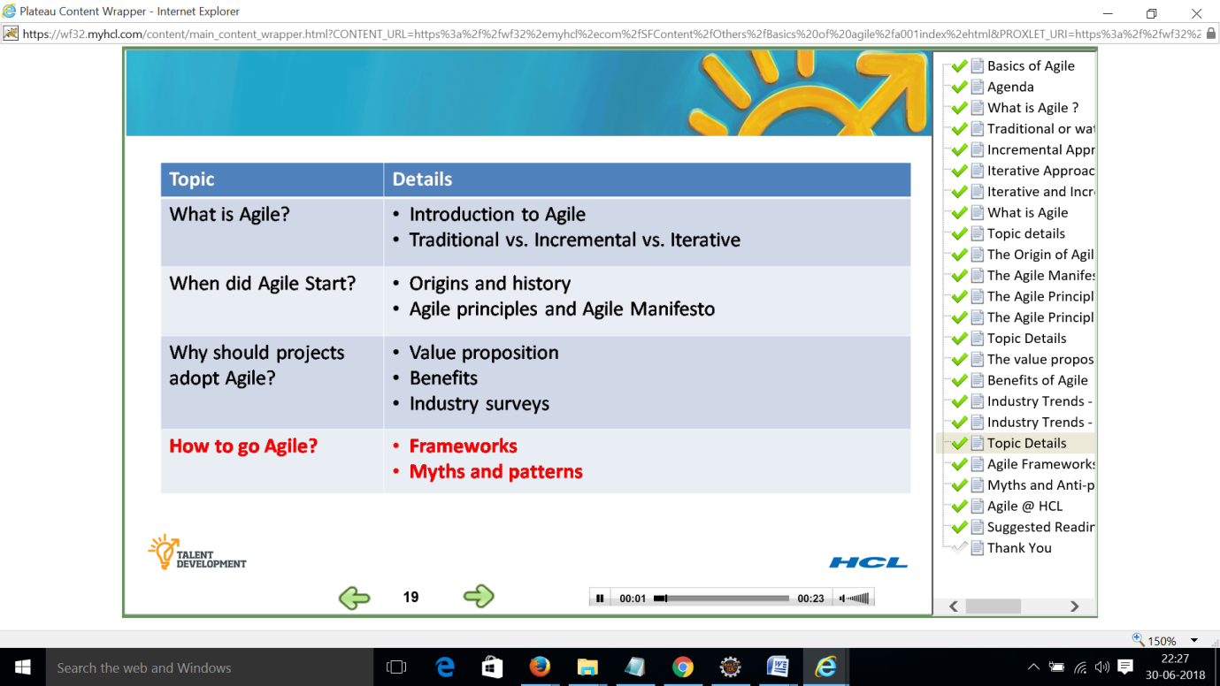

**AGILE FRAMEWORKS– SLIDE 20**

Agile is philosophy and not process

Crystal

Feature driven development

XP

Lean

Kanban

DSDM Dynamic systems development methodology

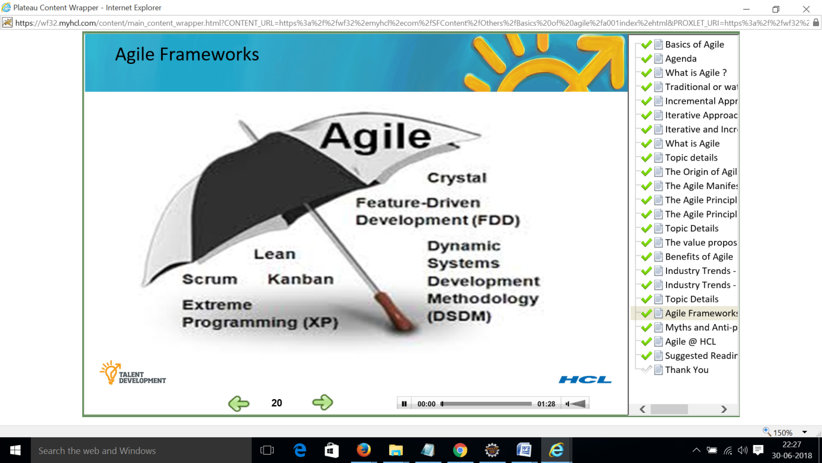

**MYTHS AND ANTI PATTERNS – SLIDE 21**

Myths

Scrum equals Agile

Documentation and coding is not disciplined

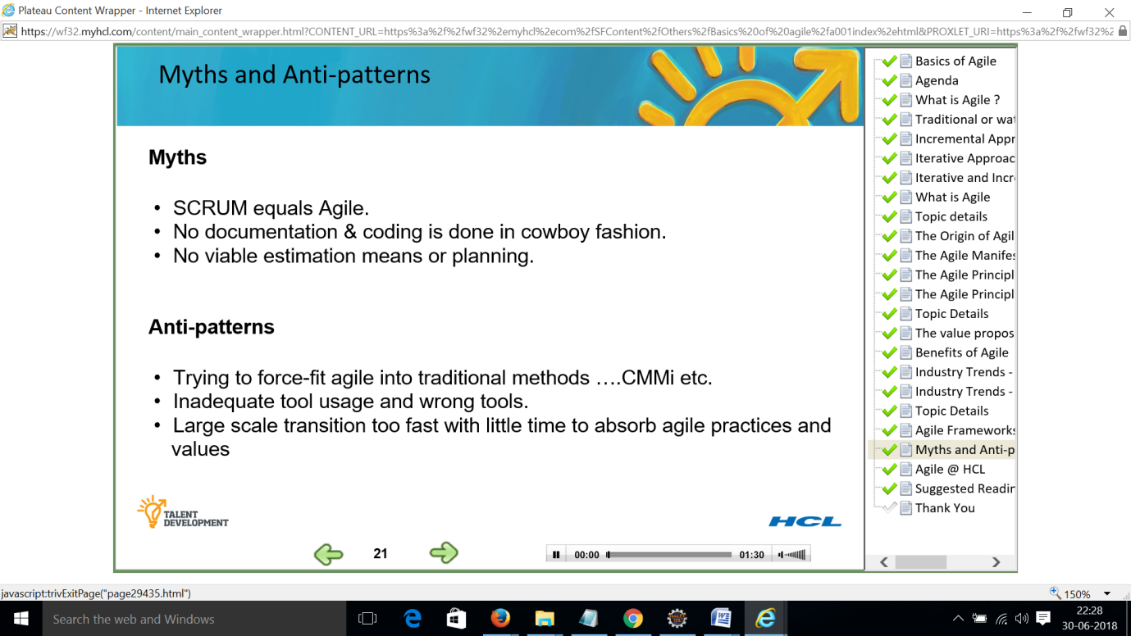

**AGILE AT HCL – SLIDE 22**

